employees.csv
emp_id,emp_name,department,job_title,salary,location,hire_date
101,Ramesh,IT,Data Engineer,95000,Bangalore,2019-06-15
102,Anita,HR,HR Executive,65000,Hyderabad,2020-02-10
103,John,Finance,Finance Manager,110000,New York,2016-09-01
104,Meena,IT,Senior Data Analyst,98000,Bangalore,2018-11-23
105,David,IT,Software Engineer,90000,San Francisco,2021-07-05
106,Priya,HR,HR Business Partner,72000,Hyderabad,2019-03-18
107,Michael,Finance,Account Director,120000,New York,2015-01-12
108,Sneha,IT,Junior Developer,78000,Bangalore,2022-08-09
109,Arjun,IT,Data Architect,115000,Bangalore,2017-05-30
110,Emily,Marketing,Marketing Manager,88000,Chicago,2018-10-17

departments.csv
dept_id,department,manager,budget,location
10,IT,Arjun Rao,500000,Bangalore
20,HR,Anita Sharma,200000,Hyderabad
30,Finance,John Smith,600000,New York
40,Marketing,Emily Wilson,300000,Chicago

🧪 Snowflake Cloning – Practical Assignments
Important Rule for Students:
❌ No CTAS
❌ No data reload
✅ Only cloning & observation

Assignment 1: Base Table Analysis
- Load both datasets into Snowflake tables
Create employee table:
create table employee (
emp_id int,
emp_name varchar (50),
department varchar (50),
job_title varchar (50),
salary int,location varchar (20),
hire_date date);
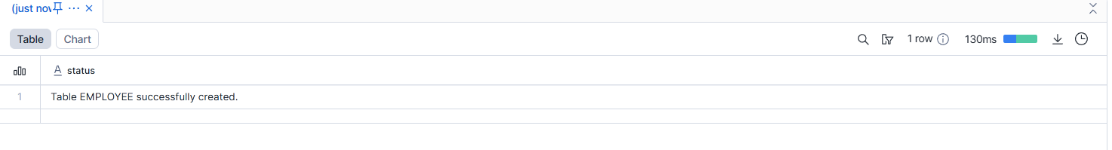
Inserted 10 records:
create table departments(
dept_id int,
department varchar (20),
manager varchar (50),
budget int,
location varchar (50)
);
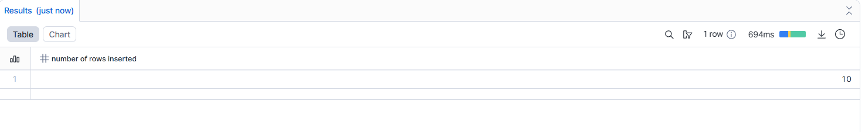
Created the departments tables:
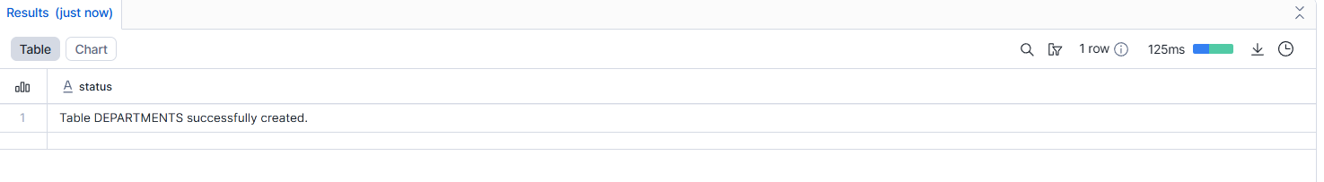
Inserted 4 records:
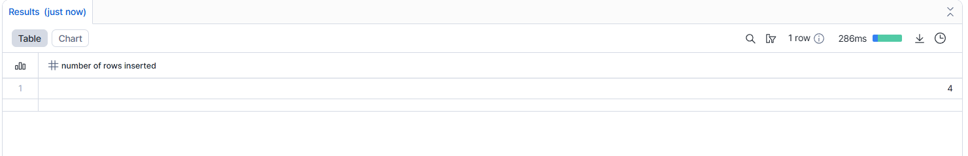
---------------------------------------------------------------------------------------------------------
- Validate row counts and data distribution
Row Counts
SELECT COUNT(*) AS employee_row_count
FROM EMPLOYEES;
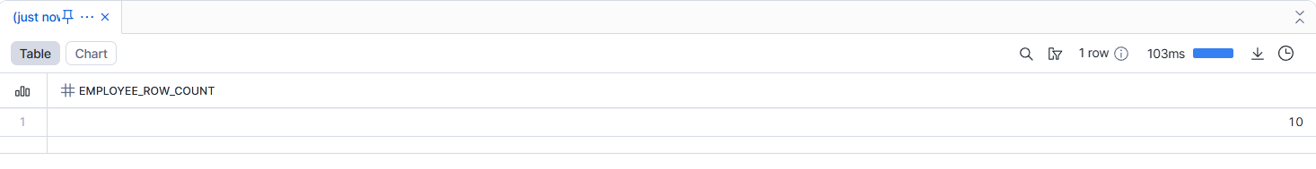
SELECT COUNT(*) AS department_row_count
FROM DEPARTMENTS;
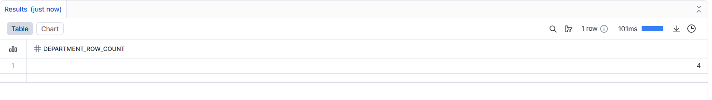
Data Distribution:
SELECT department, COUNT(*) AS employee_count
FROM EMPLOYEES
GROUP BY department
ORDER BY employee_count DESC;
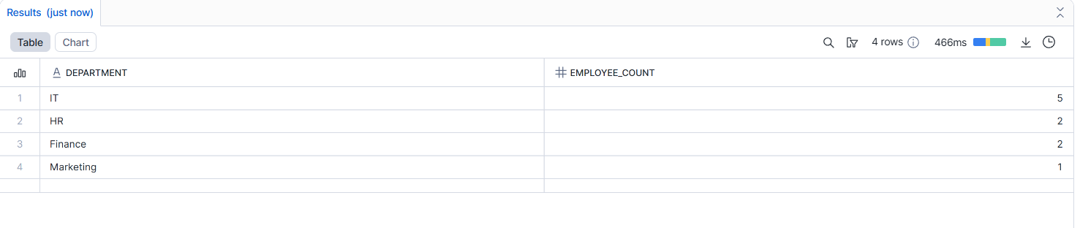
--------------------------------------------------------------------------------------------------------------------------------------
- Identify candidate tables for cloning
- Explain why these tables are suitable for cloning experiments
- • They contain real and meaningful data, which helps in clearly observing cloning behavior.
- • They include different types of data (text, numbers, dates), ensuring cloning works correctly across all columns.
- • One table is larger and the other is smaller, which helps test cloning on both complex and simple data.
- • They are stable and safe to use, allowing cloning experiments without affecting original data.

Assignment 2: Table-Level Cloning
- Clone the employee table
CREATE or replace TABLE EMPLOYEES_CLONE
CLONE EMPLOYEE;
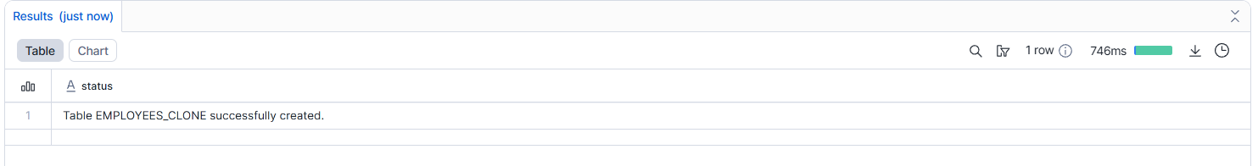
- Compare:
  - Row count
Cloned table
SELECT COUNT(*) AS clone_row_count
FROM EMPLOYEES_CLONE;
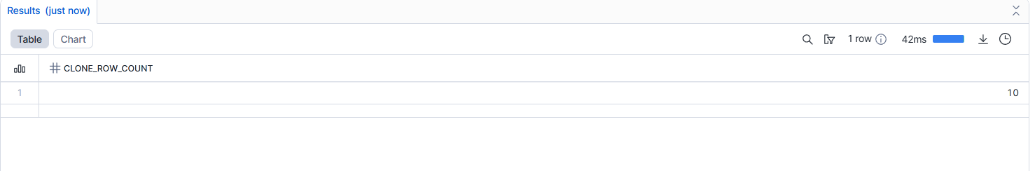
Normal table
SELECT COUNT(*) AS source_row_count
FROM EMPLOYEE;
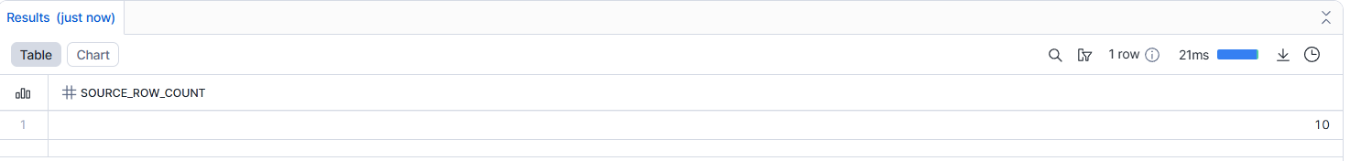
-------------------------------------------------------------------------------------------------
  - Query performance
Normal table
SELECT department, AVG(salary)
FROM EMPLOYEE
GROUP BY department;
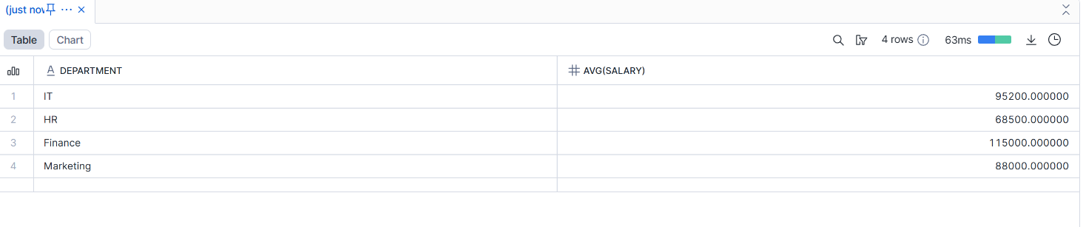
Cloned table
SELECT department, AVG(salary)
FROM EMPLOYEES_CLONE
GROUP BY department;
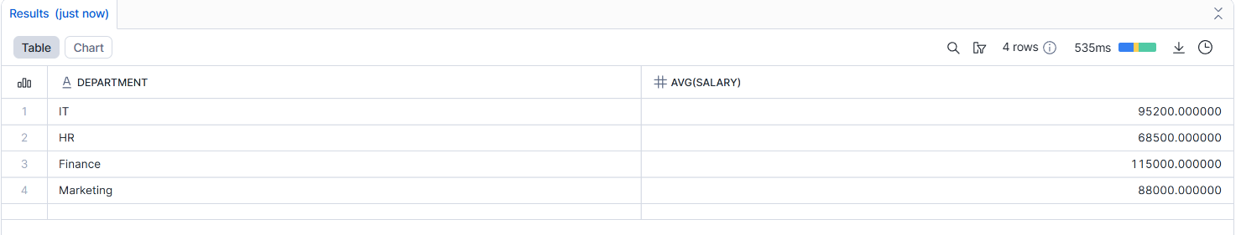
  - Storage usage
SELECT
table_name,
bytes
FROM information_schema.tables
WHERE table_name IN ('EMPLOYEE', 'EMPLOYEES_CLONE');
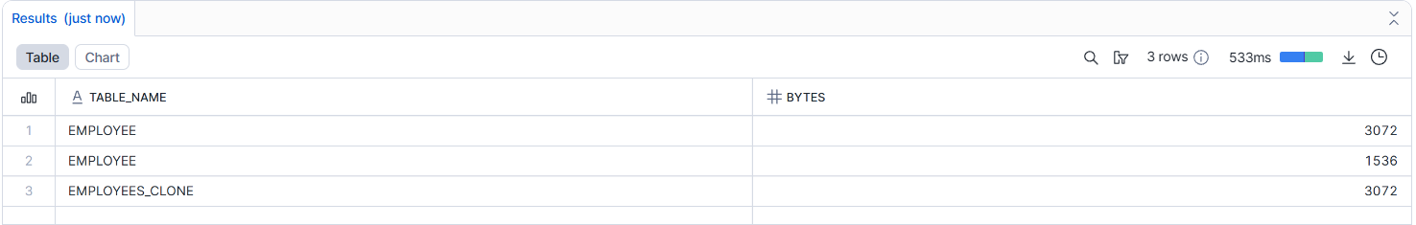
------------------------------------------------------------------------------------------
Explain why clone creation is instantaneous
- Clone creation is instantaneous because no actual data is copied.
- Only the table structure and metadata are created for the clone.
- The source table and the clone share the same underlying data storage.
- Physical data is copied only when changes are made later.

Assignment 3: Change Isolation Testing
- Update salary data in the original employee table
UPDATE EMPLOYEE
SET salary = salary + 5000
WHERE department = 'IT';
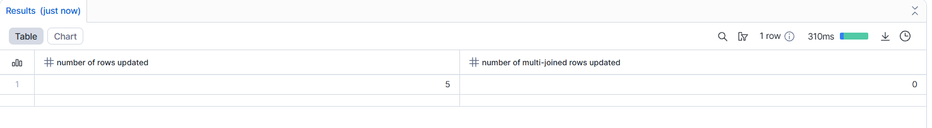
SELECT emp_id, emp_name, salary
FROM EMPLOYEE
WHERE department = 'IT';
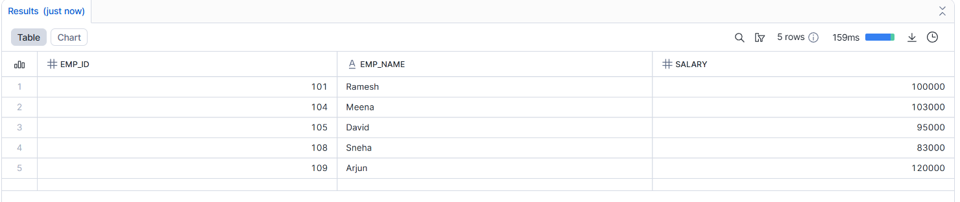
SELECT emp_id, emp_name, salary
FROM EMPLOYEES_CLONE
WHERE department = 'IT';
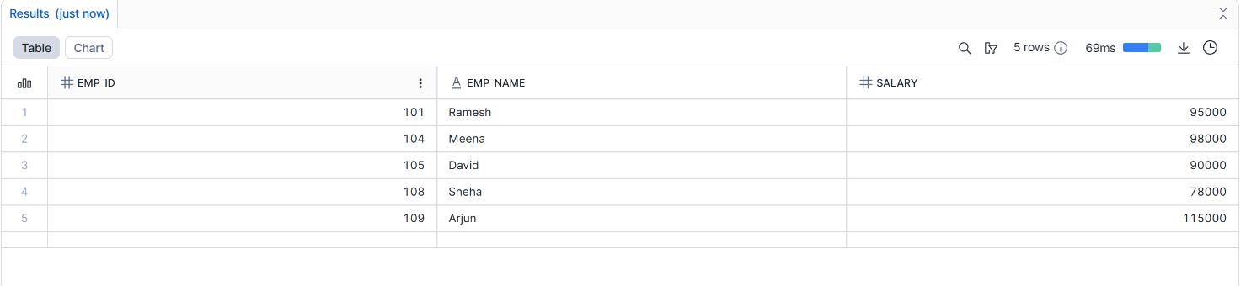
----------------------------------------------------------
- Delete records in the cloned table
DELETE FROM EMPLOYEES_CLONE
WHERE department = 'HR';
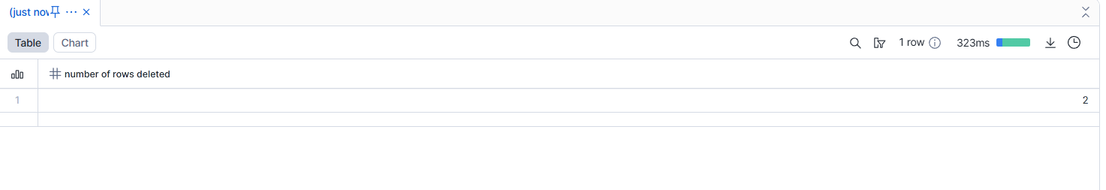
SELECT *
FROM EMPLOYEE
WHERE department = 'HR';
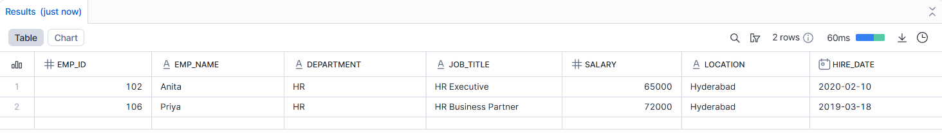
SELECT *
FROM EMPLOYEES_CLONE
WHERE department = 'HR';
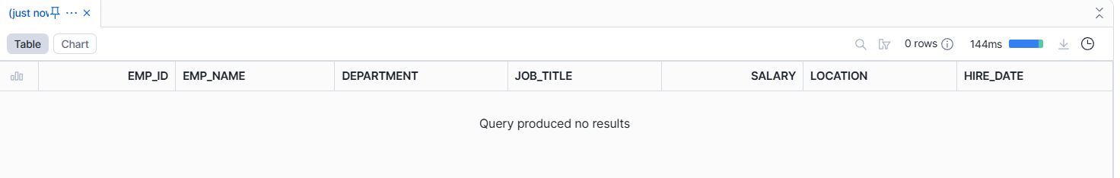
--------------------------------------------------------------
- Insert new records in the clone
INSERT INTO EMPLOYEES_CLONE
(emp_id, emp_name, department, job_title, salary, location, hire_date)
VALUES
(201, 'Test User', 'IT', 'Data Tester', 70000, 'Bangalore', '2024-01-01');
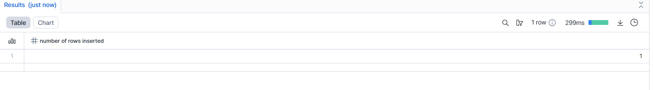
SELECT *
FROM EMPLOYEE
WHERE emp_id = 201;
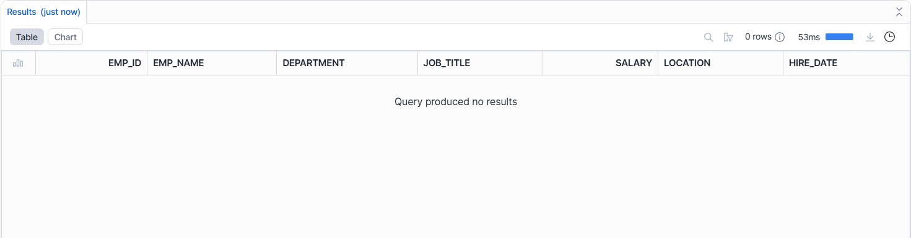
SELECT *
FROM EMPLOYEES_CLONE
WHERE emp_id = 201;
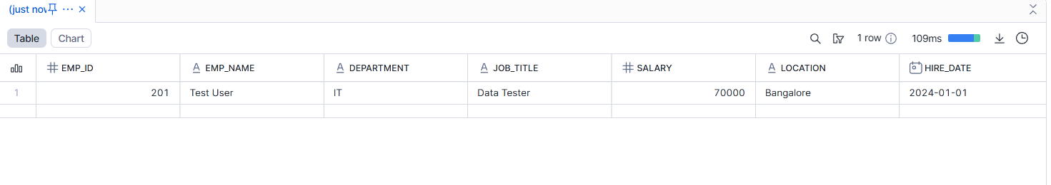
--------------------------------------------------------------------
- Validate isolation between original and clone
Explain backend copy-on-write behavior
- Original and clone are isolated after changes
- Modifications affect only the table where they are applied
- Snowflake copies data only when changes occur
- This backend behavior is known as copy-on-write

Assignment 4: Storage Growth Exploration
- Perform DML operations incrementally
SELECT
table_name,
bytes
FROM information_schema.tables
WHERE table_name IN ('EMPLOYEES_CLONE');
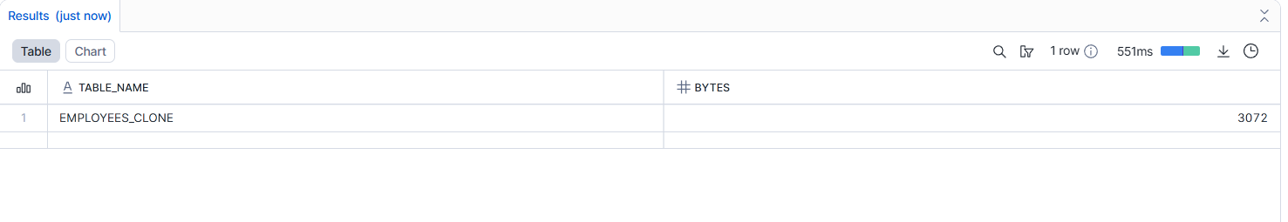
UPDATE EMPLOYEES_CLONE
SET salary = salary + 1000
WHERE department = 'IT';
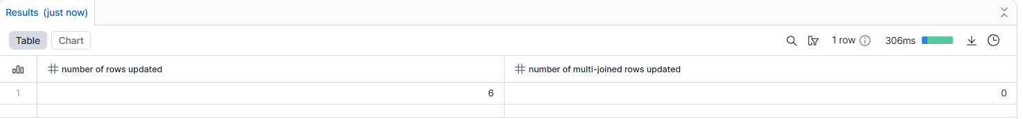
SELECT table_name, bytes
FROM information_schema.tables
WHERE table_name = 'EMPLOYEES_CLONE';
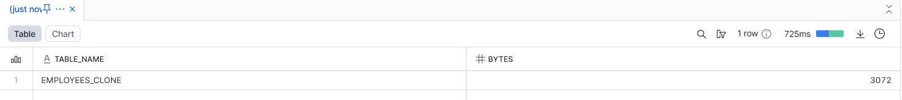
--------------------------------------------------------------------------------------------------
- Track storage before and after each operation
- Identify the exact moment storage increases

Identify the Exact Moment Storage Increases
📌 Storage increases exactly when:
- An UPDATE modifies existing rows
- An INSERT adds new rows
🚫 Storage does not reduce immediately on DELETE due to retention.
----------------------------------------------------------------------------------------------
- Explain Snowflake’s physical storage strategy
Snowflake stores data in immutable micro-partitions
When a table is cloned, data is shared, not copied
On DML operations:
- Snowflake creates new micro-partitions only for changed data
- Unchanged data continues to be shared
Deletes are handled logically and retained for Time Travel
This strategy minimizes storage usage and improves performance

Assignment 5: Time Travel Cloning
- Perform multiple updates on the original table
- Create clones from:
  - Current state
  - Past state (Time Travel)
UPDATE EMPLOYEES
SET salary = salary + 2000
WHERE department = 'IT';
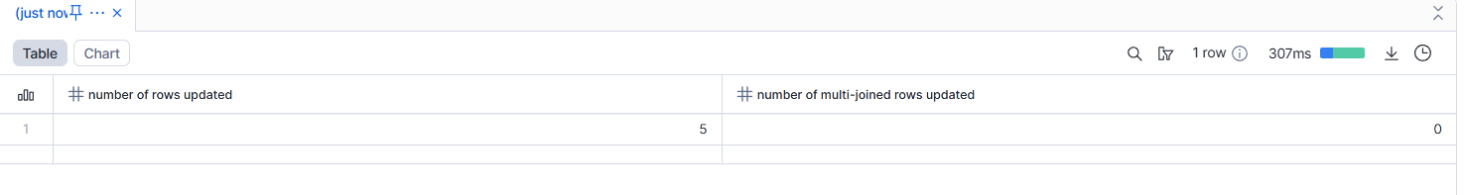
CREATE TABLE EMPLOYEES_CURRENT_CLONE
CLONE EMPLOYEES;
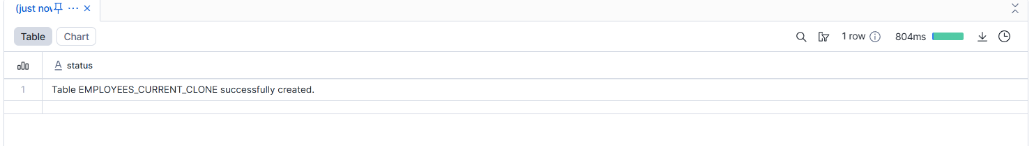
CREATE TABLE EMPLOYEES_PAST_CLONE
CLONE EMPLOYEES
AT (OFFSET => -300);
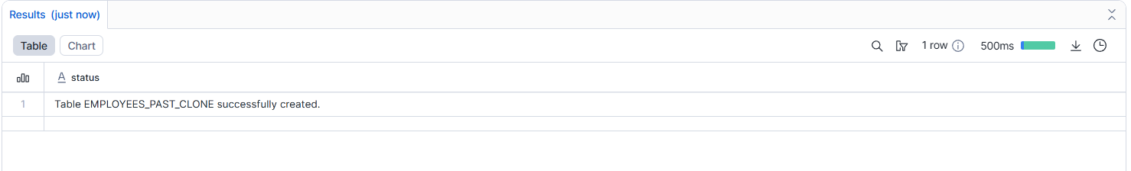
SELECT emp_id, salary
FROM EMPLOYEES_CURRENT_CLONE
WHERE department = 'IT';
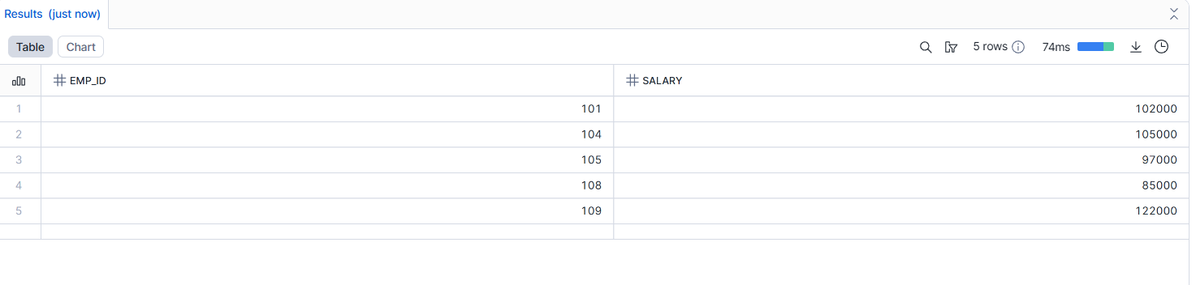
SELECT emp_id, salary
FROM EMPLOYEES_PAST_CLONE
WHERE department = 'IT';
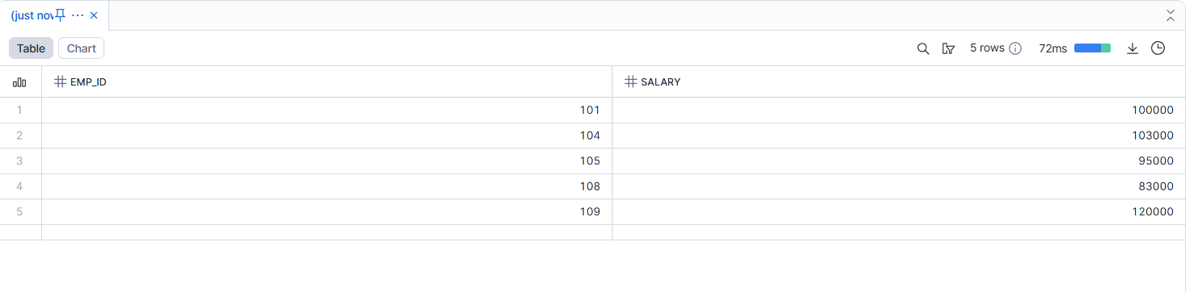
- Compare data across versions
Explain real-world recovery use cases
- If someone accidentally updates or deletes data, we can clone the table from a past point in time.
- Helps recover data without restoring backups.
- Useful for auditing and data validation, to see how data looked earlier.
- Allows safe testing and comparison of before vs after changes.
- Saves time because recovery is instant and storage-efficient.

Assignment 6: Schema-Level Cloning
- Clone a schema containing employee and department tables
show tables in schema tab_db.public;
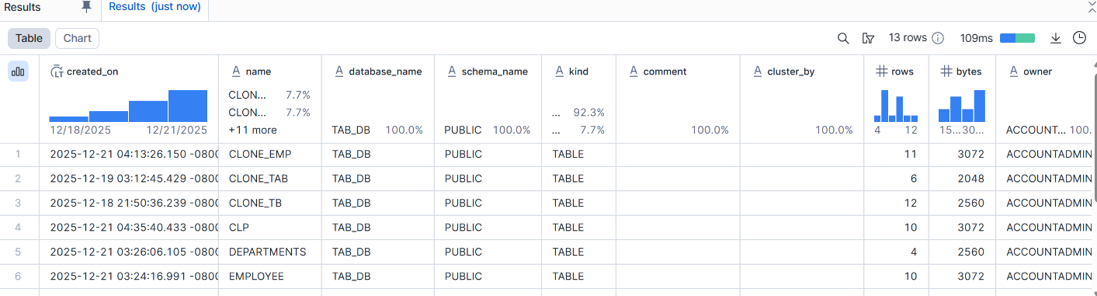create or replace schema tab_db.clone_pub_schema clone tab_db.public;
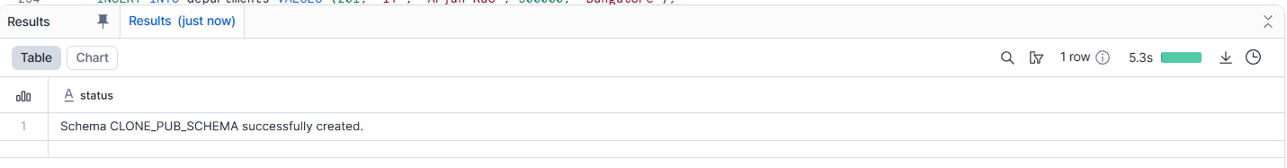
SHOW TABLES IN SCHEMA TAB_DB.clone_pub_schema;
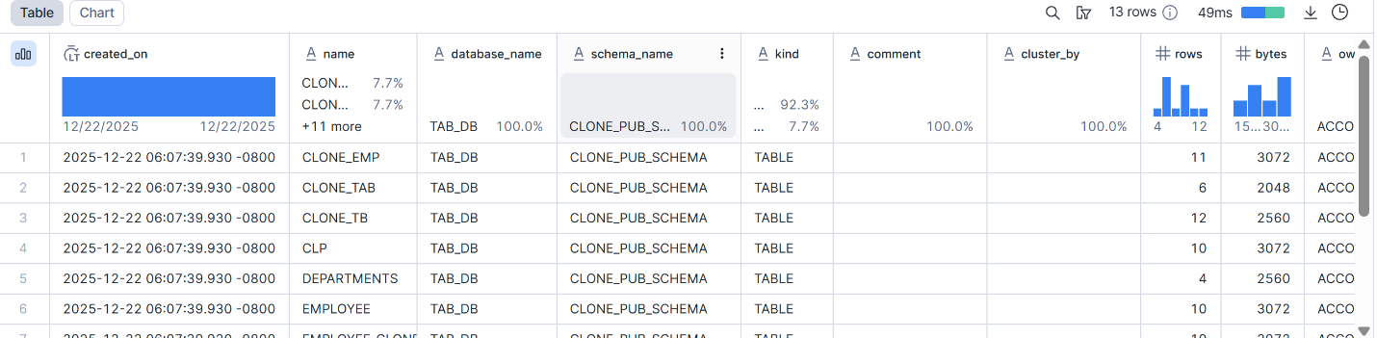
---------------------------------------------------------------------------------------
- Modify tables in cloned schema
USE SCHEMA TAB_DB.clone_PUB_schema;
UPDATE departments
SET budget = budget+ 300000
WHERE dept_id = 20;
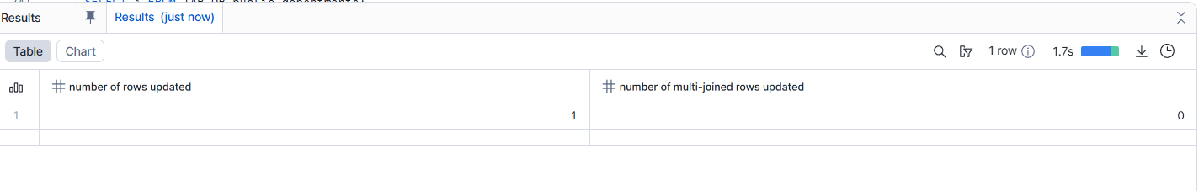
-----------------------------------------------------------------------------------------------
INSERT INTO departments VALUES (201, 'IT', 'Arjun Rao', 500000, 'Bangalore');
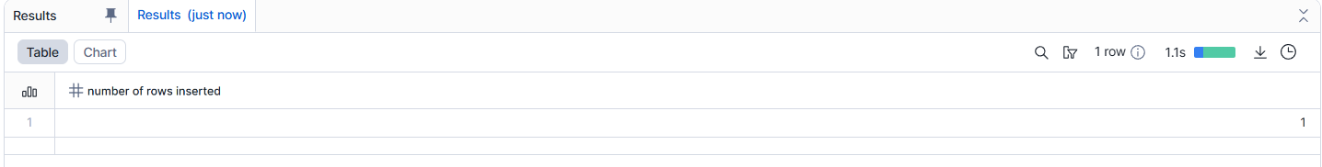
--------------------------------------------------------------------------------------------------------------------------
select*from departments;
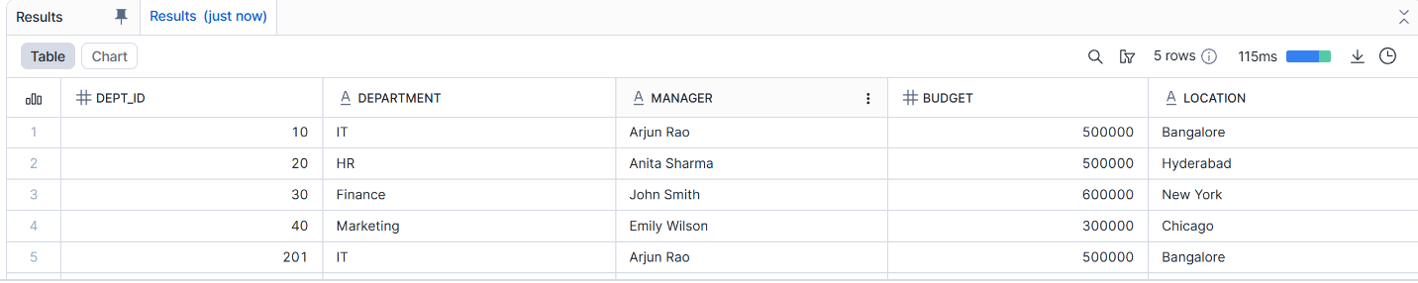
-------------------------------------------------------------
- Drop tables in original schema
DROP TABLE TAB_DB.PUBLIC.DEPARTMENTS;
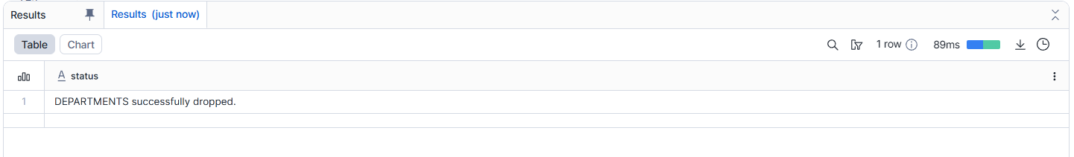
-------------------------------------------------------------------------
SHOW TABLES IN SCHEMA TAB_DB.PUBLIC;
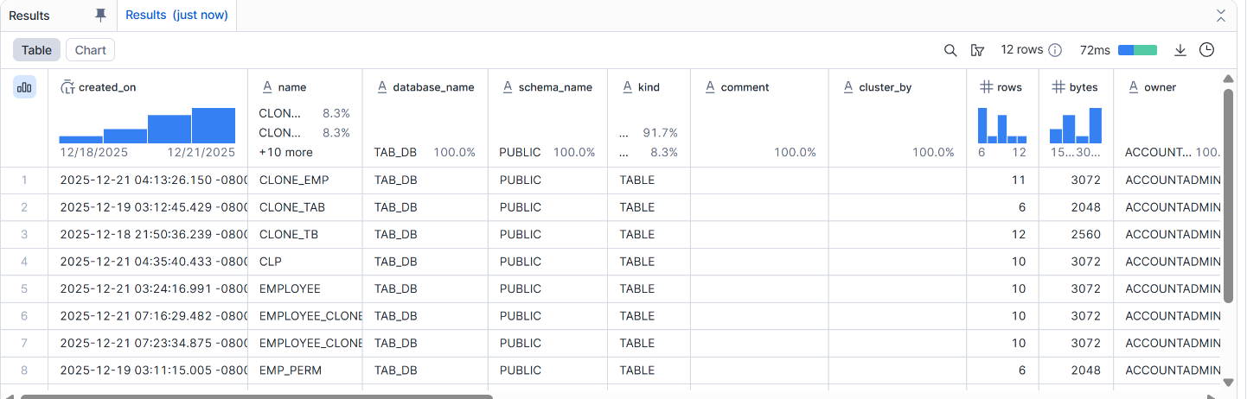
---------------------------------------------------------------------------------------------------------
SELECT * FROM TAB_DB.clone_pub_schema.departments;
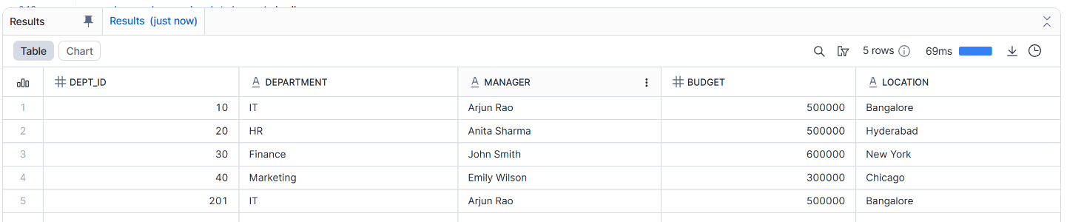
-------------------------------------------------------------------------------
SELECT * FROM TAB_DB.public.departments;
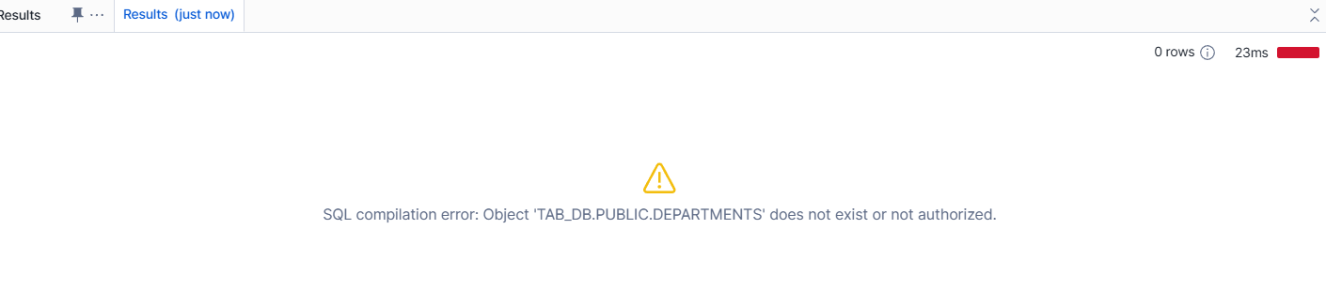
--------------------------------------------------------------------------------------------------------------------------------------
- Observe behavior and explain metadata inheritance
- When a clone is created, it immediately contains the same data and structure as the source table.
- Queries on the clone return the same results as the original at the time of cloning.
- Changes made after cloning affect only the table where the change is applied.
- Clones created from past states show data exactly as it existed at that point in time.

Assignment 7: Database-Level Cloning
- Clone the entire database
show schemas in database tab_db;
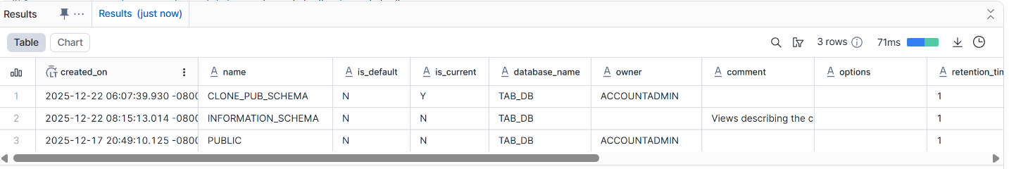
show databases;
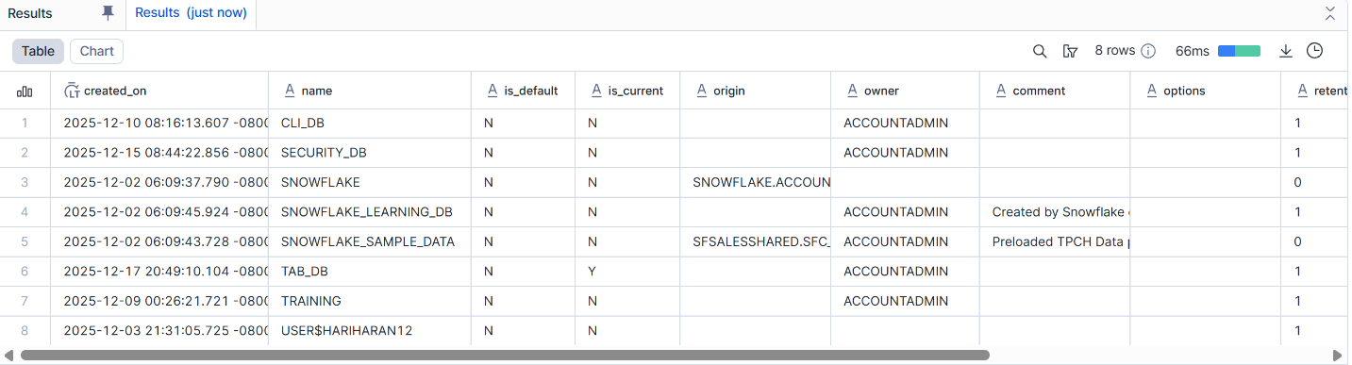
create or replace database clone_tab_db clone tab_db;
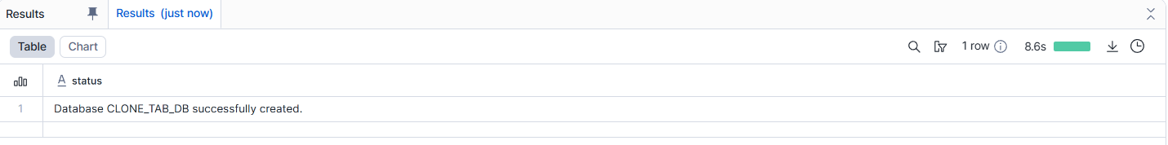
- Test query access and object availability
USE DATABASE clone_tab_db;
SELECT * FROM PUBLIC.EMPLOYEE;
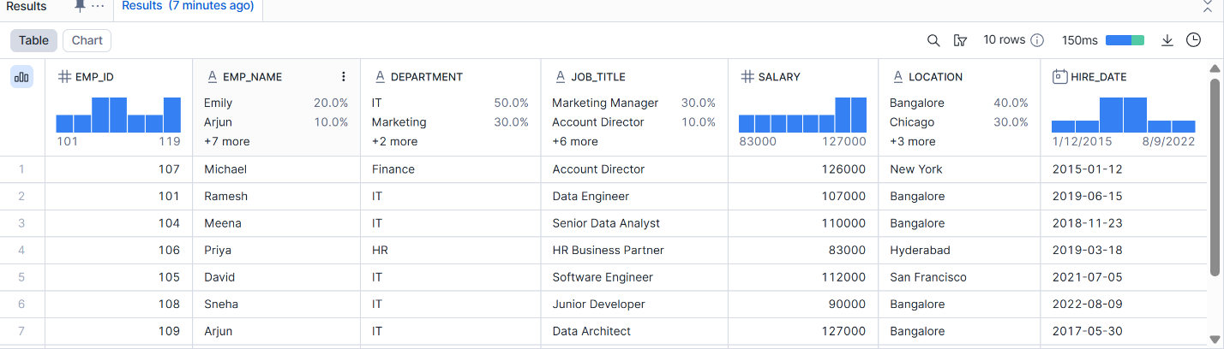
- Perform DML on cloned database
UPDATE clone_tab_db.PUBLIC.EMPLOYEE
SET salary = salary + 3000 WHERE emp_id = 104;
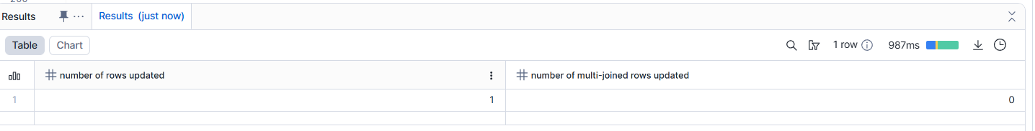
insert into clone_tab_db.public.employee values(301, 'Ramesh', 'IT', 'Data Engineer', 95000, 'Bangalore', '2019-06-15');
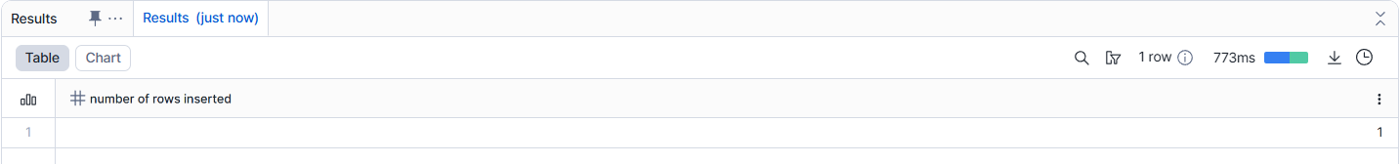
SELECT * FROM TAB_DB.PUBLIC.EMPLOYEE WHERE emp_id = 104;
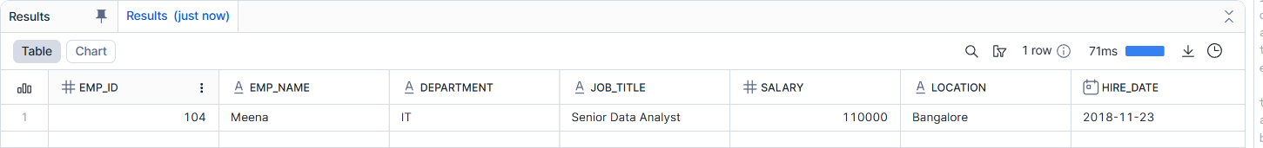
SELECT*FROM CLONE_TAB_DB.PUBLIC.EMPLOYEE WHERE EMP_ID=104
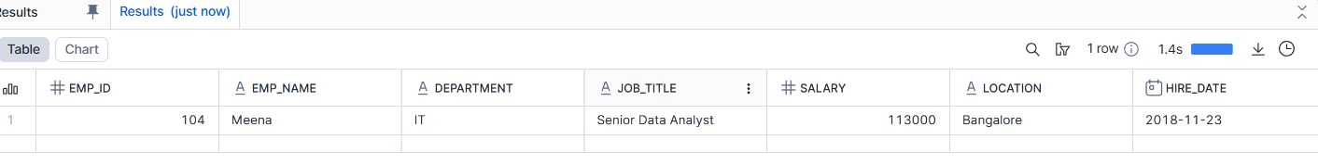

Explain how Snowflake isolates environments (Dev/Test/Prod)
- Each environment (Dev, Test, Prod) is created as a separate database or schema, so changes in one environment do not affect others.
- Snowflake allows cloning of databases or tables, so Test or Dev can be created from Prod data without copying data, while still remaining isolated.
- Role-based access control ensures that users have access only to the environment they are assigned to (for example, developers cannot change Prod data).
- Even though data can be shared using cloning, any changes made in one environment stay only in that environment, ensuring full isolation and safety

Assignment 8: Privileges & Security
- Analyze access privileges before cloning
SHOW GRANTS ON TABLE EMPLOYEE;
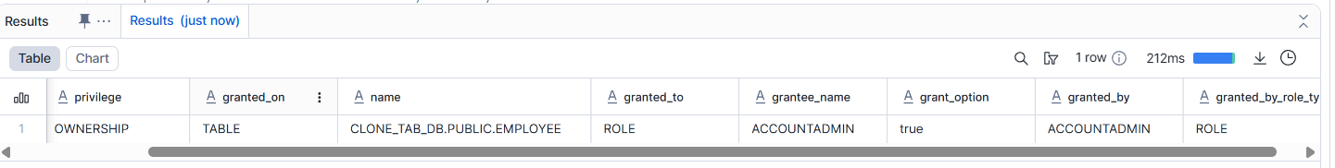
- Observe privileges after cloning
SHOW GRANTS ON TABLE CLONE_EMP;
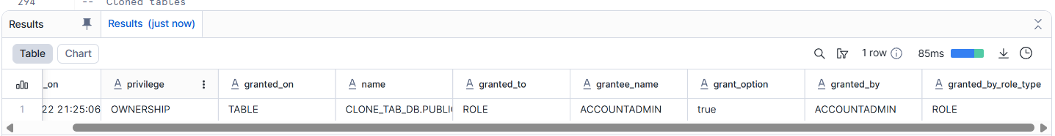
- Modify privileges on clone
SHOW GRANTS ON TABLE CLONE_EMP;
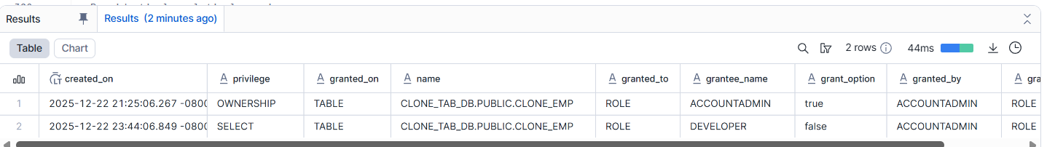
Explain why Snowflake handles security this way
* Snowflake uses role-based access control so users can access only what they are authorized to use.
* Separating environments (Dev, Test, Prod) reduces the risk of accidental changes to production data.
* Cloning allows teams to work with real data without exposing or modifying the original data.
* Centralized security management makes it easier to audit, control, and enforce policies.
--------------------------------------------------------------------------------------------------------------------------------------
Assignment 9: Performance Comparison
- Run identical analytical queries on:
Original tables:
use tab_db;
select department,avg(salary) as department_avgsal from employee group by department order by department_avgsal desc;
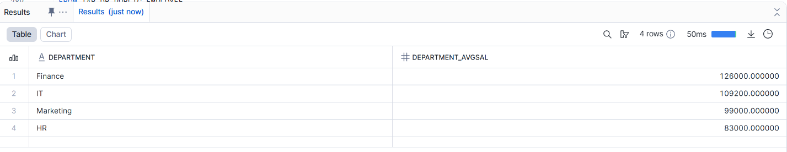
Cloned tables:
use clone_tab_db;
select department,avg(salary) as department_avgsal from employee group by department order by department_avgsal desc;
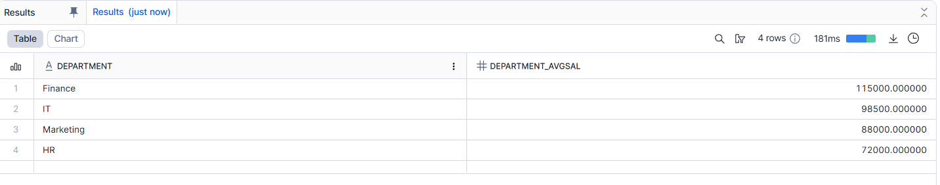
- Compare execution plans:
SELECT department, AVG(salary)as department_avgsal
FROM TAB_DB.PUBLIC.EMPLOYEE
GROUP BY department order by department_avgsal desc;
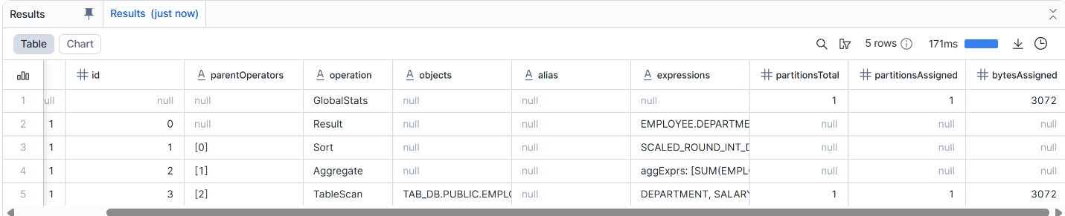
SELECT department, AVG(salary)as department_avgsal
FROM clone_TAB_DB.PUBLIC.clone_EMP
GROUP BY department order by department_avgsal desc;
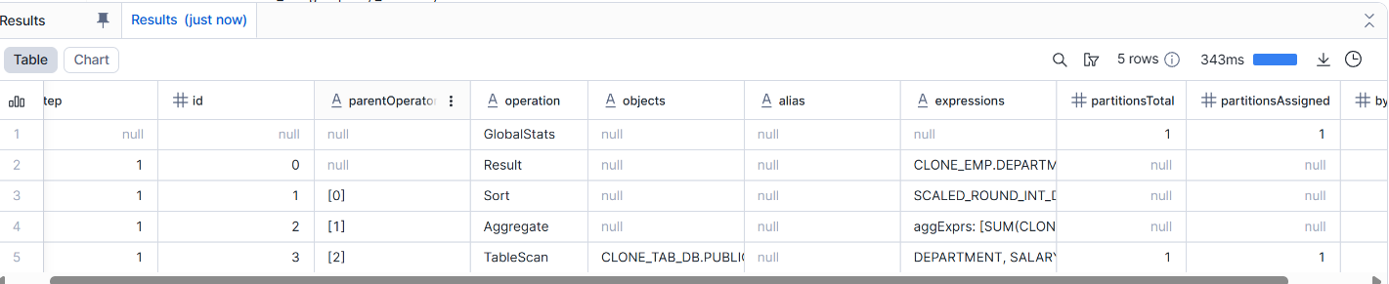
SELECT
query_text,
execution_time,
bytes_scanned
FROM snowflake.account_usage.query_history
WHERE query_text ILIKE '%AVG(salary)%'
ORDER BY start_time DESC;

Assignment 10: Cleanup & Retention
- Drop original objects
DROP TABLE TAB_DB.PUBLIC.EMPLOYEE;
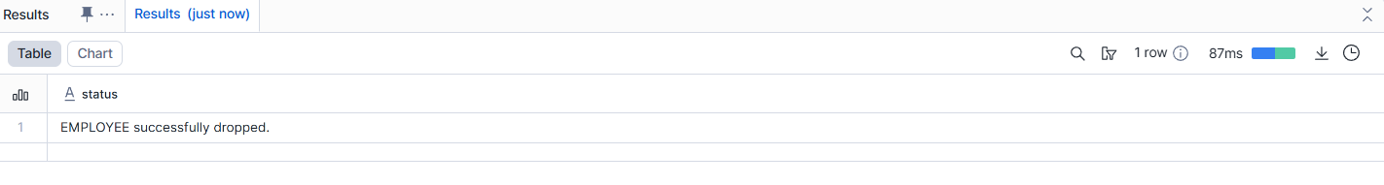
select*from tab_db.public.employee; -----doesnt exist

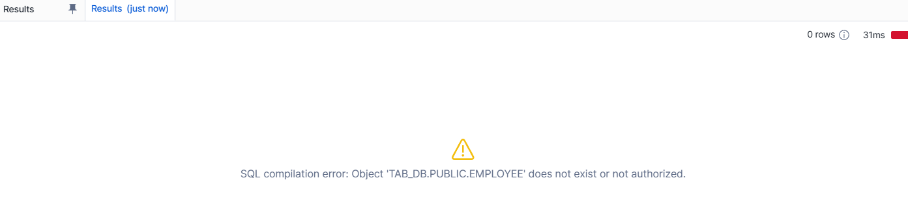
- Validate cloned object availability
SELECT * FROM CLONE_tab_db.PUBLIC.EMPLOYEE;
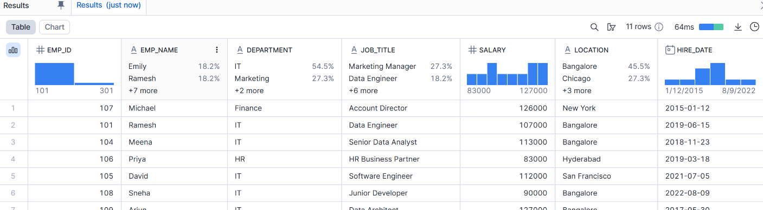
- Drop clone and analyze Time Travel behavior
DROP TABLE CLONE_tab_db.PUBLIC.EMPLOYEE;
SELECT * FROM CLONE_tab_db.PUBLIC.EMPLOYEE; --- its showing doent exist
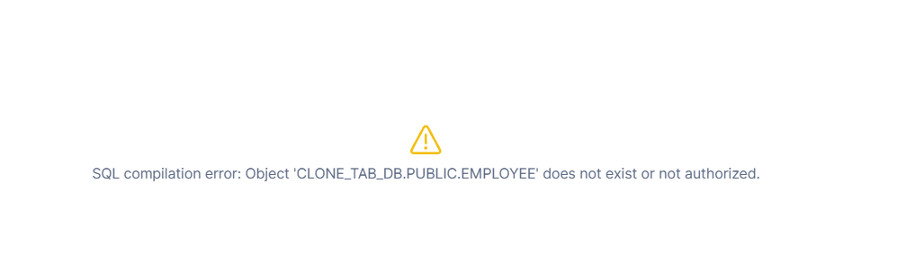Recover Clone Using Time Travel (UNDROP)
undrop table clone_tab_db.public.employee;
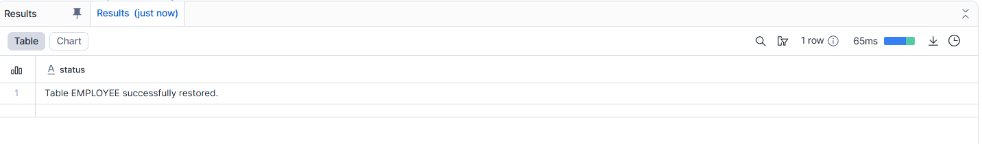
--Verify Data After UNDROP:
SELECT * FROM CLONE_tab_db.PUBLIC.EMPLOYEE;
